25VL798
INDUSTRY INTERNSHIP
RTL Design, Analysis, and Verification
Week - 1

A Report
Submitted by
abhiram b (CB.EN. P2VLD25001)
poornesh PARCHURU (CB.EN. P2VLD250021)
srujan m n (CB.EN. P2VLD250031)
Yaganti Pavan sai (CB.EN. P2VLD250037)

Department of Electronics and Communication Engineering,
Amrita School of Engineering,
Amrita Vishwa Vidyapeetham,
Coimbatore – 641112

March 2026
Date : 16-05-2026

1.AIM
To perform RTL-level analysis and verification of benchmark circuits using industry-standard Synopsys EDA tools, establishing a quality-checked RTL baseline before proceeding to logic synthesis.

2. Objective:
- Analyze and verify the RTL design of benchmark circuit S27 (sequential) using the Synopsys SpyGlass tool for static RTL analysis.
- Perform RTL linting using SpyGlass to identify and resolve connectivity issues, coding violations, latch inference, simulation mismatches, and synthesis-incompatible constructs.
- Validate design constraints by creating and loading SGDC files for each circuit and verifying clock definitions, I/O delay coverage, and constraint completeness through SpyGlass checks.
- Consolidate all analysis reports – lint into a comparative study across the benchmark circuits and prepare workflow documentation and demo video.

3. Tool Flow:
SpyGlass Explorer is a Synopsys static analysis platform that performs RTL quality checks without simulation. It reads HDL files, elaborates the design, and runs rule-based checks across lint, CDC, DFT, power, and constraint domains.
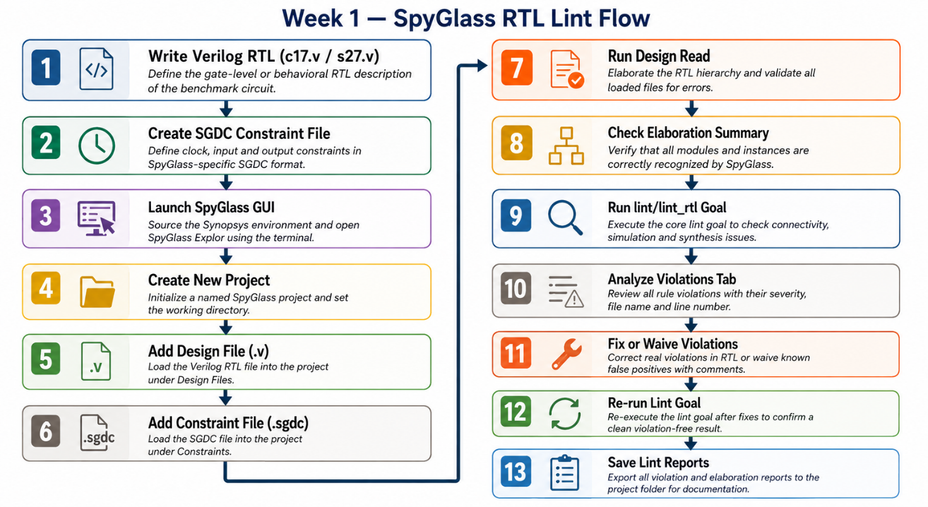

3.1 What SpyGlass checks
Goal Group | License | What it checks
lint | SpyGlass Lint | Connectivity, floating wires, latch inference, simulation issues, synthesis issues
constraints | SpyGlass Constraints | SDC/SGDC completeness, timing path coverage
cdc | SpyGlass CDC | Clock domain crossings, missing synchronizers
dft | SpyGlass DFT | Scan readiness, testability, controllability
power | SpyGlass Power | Clock gating, power coding style, UPF rules

3.2 Input and output files
File | Format | Purpose
Design RTL | .v / .sv | Verilog or SystemVerilog source files
Constraints | .sgdc | SpyGlass-specific clock, I/O constraint format
Power intent | .upf | Unified Power Format — power domain definitions
Tech library | .lib / .db | Standard cell library for gate-level checks
Waiver file | .awl | Suppress known false violations
Lint reports | .rpt | Rule violations with file/line references
Elab summary | .rpt | Elaborated design units and hierarchy

4. Design Under Analysis — S27 Benchmark

The S27 benchmark is a small sequential circuit from the ISCAS-89 benchmark suite. It is used in Week 1 to demonstrate SpyGlass analysis on a design with flip-flops, a clock signal, and combinational logic.

4.1 Design specifications
Parameter | Value
Module name | s27
Inputs | CK, G0, G1, G2, G3
Output | G17
Flip-flops | 3 x D flip-flops (DFF_0, DFF_1, DFF_2)
Gates | 8 gates: 1 AND, 1 NAND, 2 OR, 4 NOR, 2 NOT
Clock | CK — posedge triggered
Benchmark family | ISCAS-89 sequential

4.2 SGDC constraint file
SpyGlass uses the SGDC (SpyGlass Design Constraints) format. The syntax differs from SDC — use native SGDC commands as shown below.

File: s27.sgdc
# SpyGlass Design Constraints — S27 benchmark
# Sequential: 3 D flip-flops, 1 clock (CK), 4 inputs, 1 output
current_design s27
# Clock definition — CK is the real clock, 10ns period
clock -name CK -period 10
# Input constraints referenced to CK
input -name {G0 G1 G2 G3} -clock CK
# Output constraint referenced to CK
output -name {G17} -clock CK

# Reset — S27 has no explicit reset port, so none defined
NOTE: Do not use create_clock or set_input_delay — those are SDC commands and cause SGDCSTX_002 errors in SpyGlass. Use clock, input, output instead.
5. Launching SpyGlass

5.1 Environment setup and launch

Open a terminal and run the following commands to set up the Synopsys environment and launch SpyGlass:

csh
source /home/synopsys/setup_18.csh
spyglass &

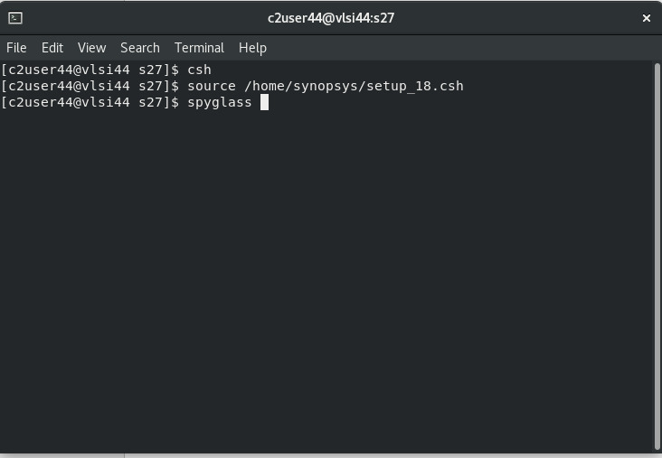

Figure: SpyGlass Explorer — Initial launch screen

NOTE: The & symbol launches SpyGlass in the background so the terminal remains usable. The sg_shell prompt appears at the bottom of the GUI.

6. Project Setup — Design Setup Tab

All file loading is done in the Design Setup tab. Follow these steps in order.

6.1 Open the Add File(s) dialog

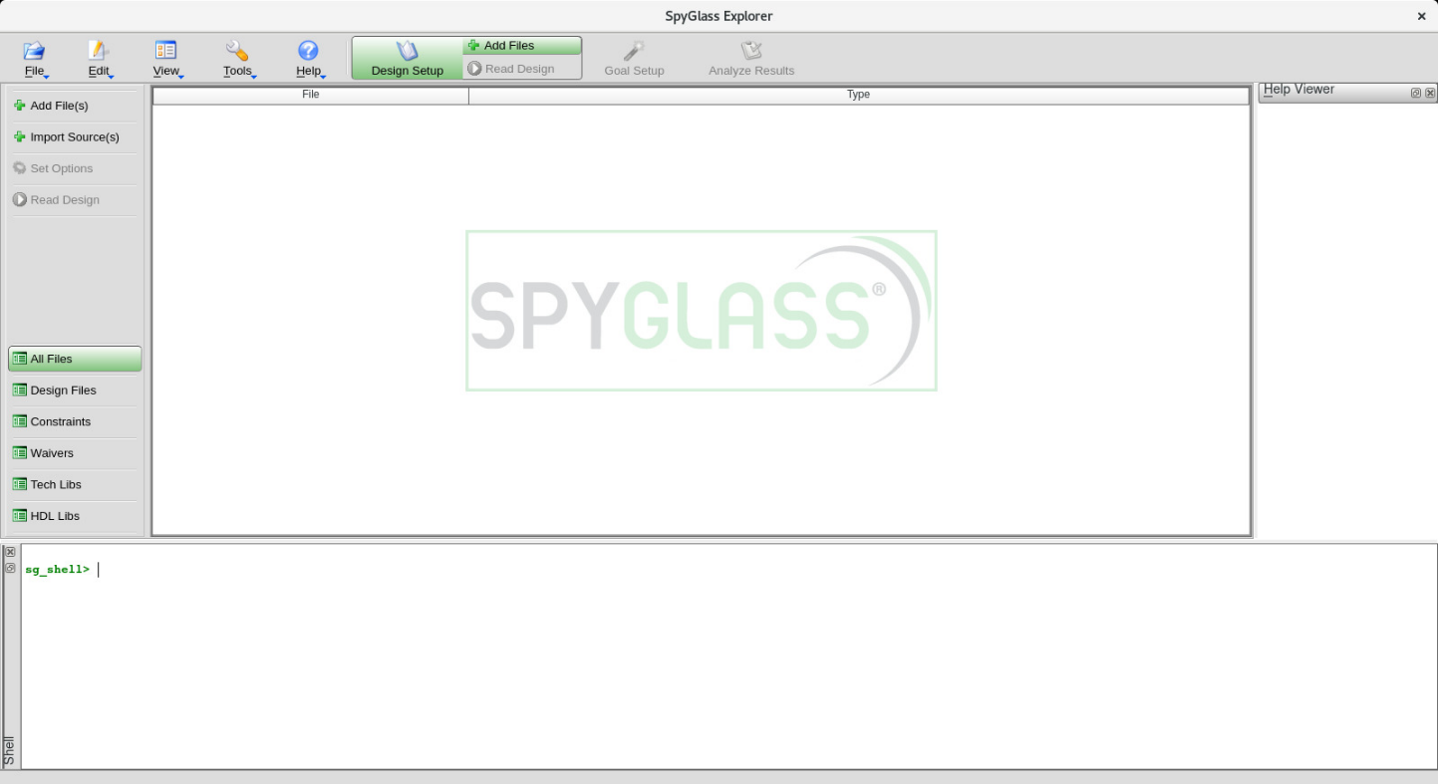
Click Add File(s) in the left panel or the toolbar. The file browser opens showing your working directory.
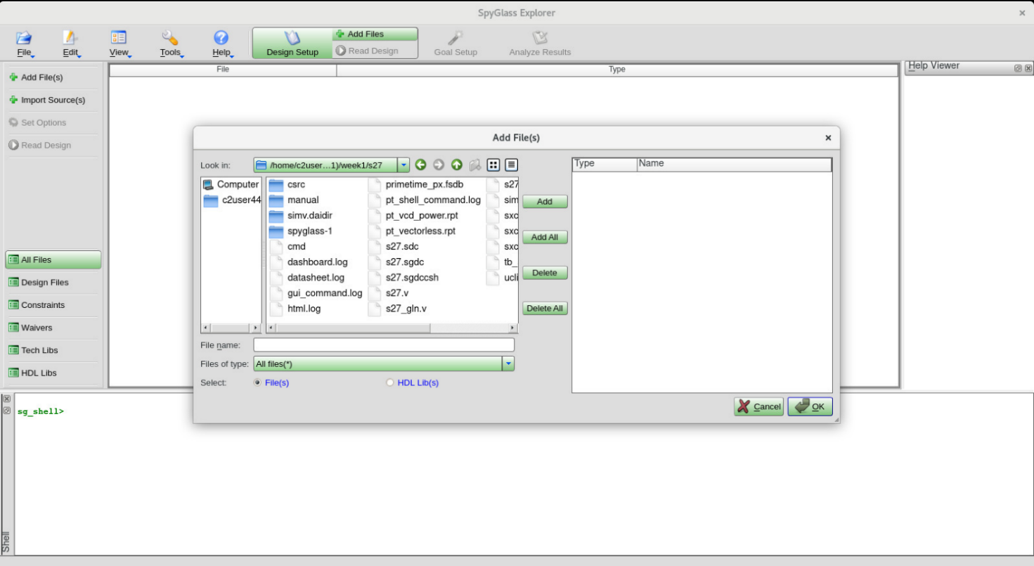
Figure: Add File(s) dialog — showing s27 project folder

6.2 Add files in the correct order

Step | File | Type in dialog | Action
1 | s27.v | Verilog | Select file → click Add
2 | s27.sgdc | Sgdc (auto-detected) | Select file → click Add
3 | s27.upf | UPF | Select file → click Add (if available)
4 | tech.lib | Tech Libs section | Select file → click Add (if available)
5 | — | — | Click OK to confirm all files

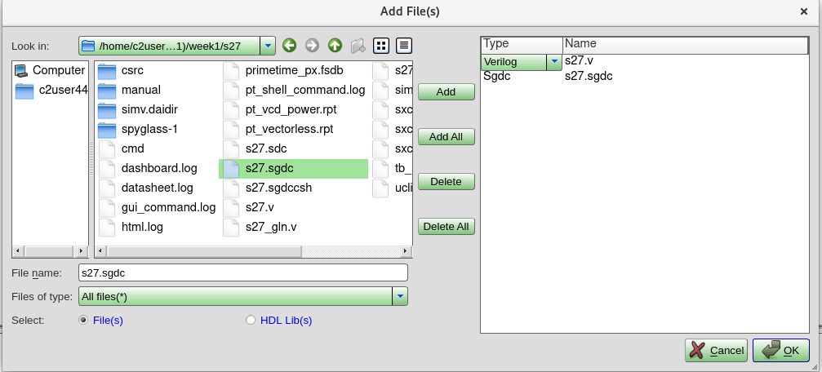

Figure: Files added — s27.v (Verilog) and s27.sgdc (Sgdc) visible in file list

NOTE: SpyGlass auto-detects the file type based on the extension. Verify each file shows the correct type in the Type column.

7. Design Read
After adding all files, click Read Design in the left panel. SpyGlass elaborates the RTL, resolves module hierarchy, and validates the SGDC file.

7.1 Read Design results
On successful read, the Violations tab at the bottom shows Design Read messages. Check for the following:
Message | Severity | Meaning
Module s27 is a top level design unit | INFO | Top module correctly identified
No cell has been picked from sglib | INFO | No tech lib loaded — acceptable for RTL lint
ElabSummary — elab_summary.rpt | INFO | Design elaborated successfully
SGDCSTX_002 — Unknown SGDC command | ERROR | Wrong SGDC syntax — fix the .sgdc file
SGDCSTX_003 — Incorrect field name | ERROR | Invalid field in SGDC command — fix the .sgdc file

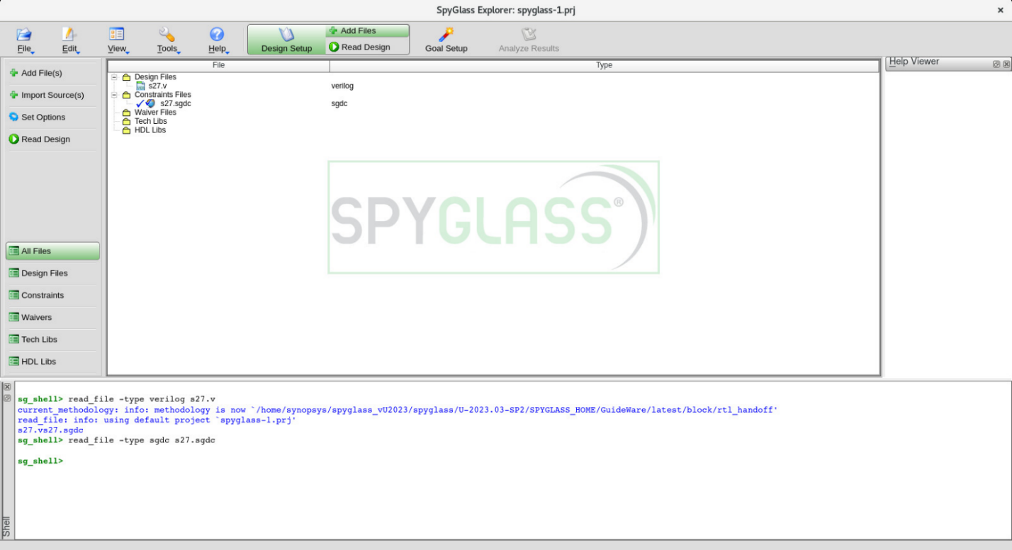

Figure: Added Files — s27.v (Verilog) and s27.sgdc (Sgdc) ready for design read

8. Goal Setup

Click the Goal Setup tab. The left panel lists all available goal groups. The methodology shown is GuideWare/latest/block/rtl_handoff — the standard RTL handoff methodology for new block development.
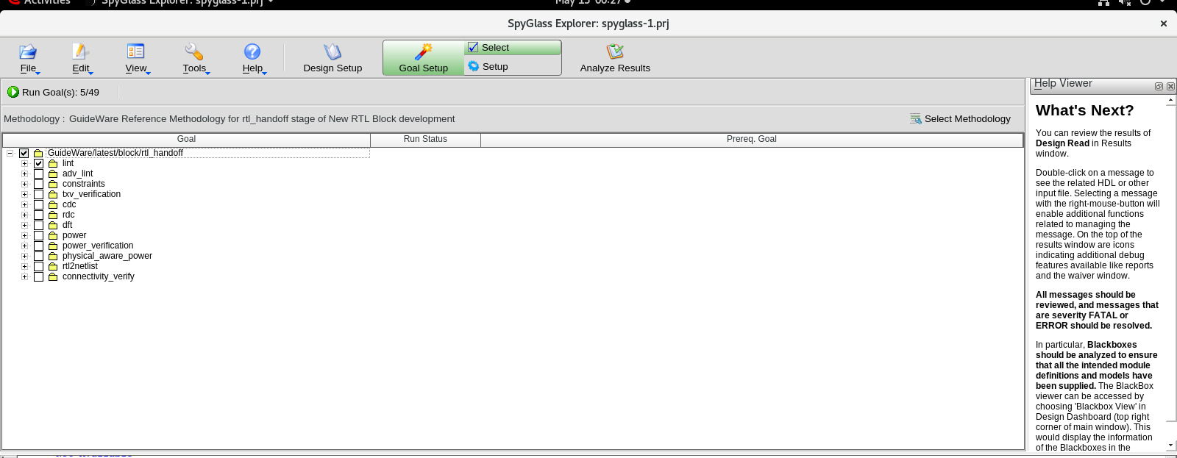
Figure: Goal Setup tab — showing all available goal groups

8.1 Available goal groups
Goal Group | Description
lint | Core RTL lint — connectivity, simulation, synthesis, structural checks
adv_lint | Advanced lint — deeper structural and coding style rules
constraints | SDC/SGDC completeness and consistency checks (requires license)
txv_verification | Transaction-level verification checks
cdc | Clock domain crossing analysis
rdc | Reset domain crossing analysis
dft | Design for testability — scan readiness
power | RTL power analysis — clock gating, power intent
power_verification | UPF power domain rule verification
physical_aware_power | Physical-aware power checks
rtl2netlist | RTL to netlist consistency checks
connectivity_verify | Hierarchical connectivity verification

9. Running Lint — lint/lint_rtl

Expand the lint group in the Goal Setup panel. Select lint/lint_rtl and click Run Goal(s). This is the most important goal for Week 1.

9.1 What lint/lint_rtl checks
- Connectivity issues — floating inputs, undriven outputs, unconnected ports
- Width mismatch — port connections with mismatched bit widths
- Simulation issues — incomplete sensitivity lists, race conditions, blocking/non-blocking mixing
- Structural issues — design constructs that may cause unexpected behavior
- Synthesis issues — non-synthesizable constructs

9.2 Analyze Results tab
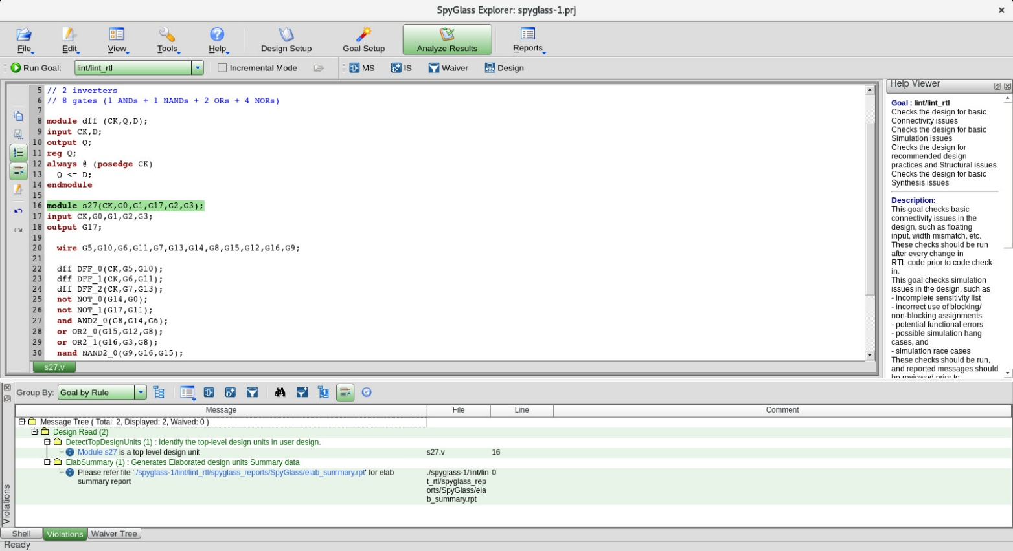
After the goal completes, SpyGlass switches to the Analyze Results tab automatically. The bottom panel shows the Violations tab with all findings.

Figure: Analyze Results — lint/lint_rtl goal with Violations tab

9.3 Elaboration summary report
After Design Read, open the elab_summary.rpt file to verify both modules were elaborated correctly:
- Elaborated Name: 'dff' — with 3 instances (DFF_0, DFF_1, DFF_2)
- Elaborated Name: 's27' — top module at line 16 of s27.v
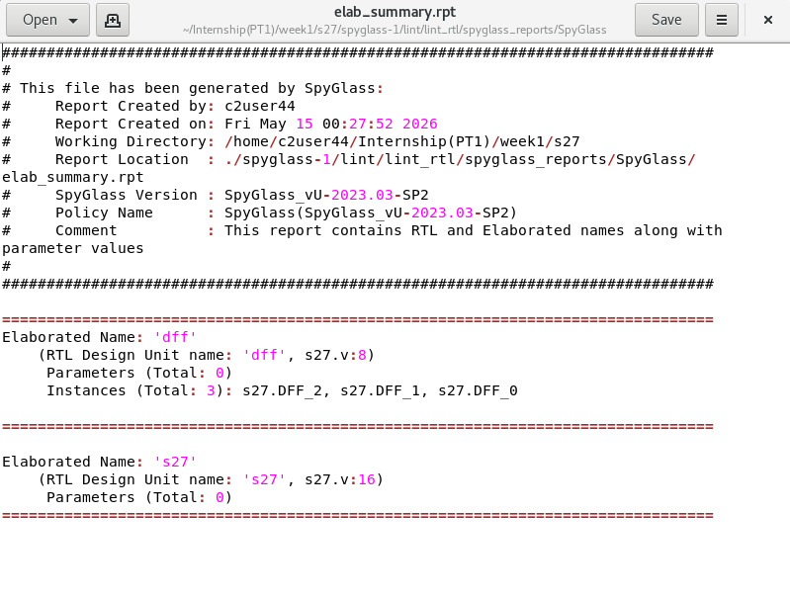

Figure: elab_summary.rpt — showing dff and s27 elaboration

9.4 Understanding the violations panel
Column | Example | Meaning
Message | DetectTopDesignUnits | Rule ID and description of the finding
File | s27.v | Source file where the violation was found
Line | 16 | Line number in the source file
Comment | — | Waiver comment if violation has been waived

9.5 Expected results for S27
Message | Type | Action
DetectTopDesignUnits — s27 is top level | INFO | Expected — no action needed
ElabSummary — refer elab_summary.rpt | INFO | Expected — open and verify report
CMD_sglib03 — no cell from sglib | INFO | Expected — no tech lib loaded
Any ERROR violations | ERROR | Must investigate and fix or waive

10. Saving Reports
After each goal run, save the report for documentation.

10.1 Save from Reports menu
- Click Reports in the top menu bar
- Click Save Report
- Name the file to match the goal — e.g. s27_lint_rtl.rpt
- Save to your project folder

10.2 Report files to collect
Report file | Contents
s27_lint_rtl.rpt | All lint violations with rule IDs, file, and line numbers
elab_summary.rpt | Elaborated modules, instances, and parameters
s27_cdc.rpt | Clock domain crossing findings (if CDC goal licensed)
s27_dft_scan.rpt | Scan readiness findings (if DFT goal licensed)
s27_power.rpt | RTL power lint findings (if Power goal licensed)

11. Common Errors and Fixes

Error | C  ause | Fix
SGDCSTX_002 — Unknown SGDC command | Using SDC syntax (set_input_delay, create_clock) | Use SGDC syntax: clock, input, output
SGDCSTX_003 — Incorrect field name | Using -port field in clock command | Remove -port, use only -name and -period
constraintsso — No such feature | Constraints license not available | Skip constraints goal, run lint goals only
CMD_sglib03 — No cell from sglib | No tech lib loaded | INFO only — acceptable for RTL lint
Design Read: FATAL errors | RTL syntax error in .v file | Fix the Verilog file and re-run Read Design

12. Quick Reference — Complete Flow
Step | Action | Result
1 | Launch SpyGlass | source setup.csh → spyglass &
2 | Add s27.v | File type: Verilog — appears under Design Files
3 | Add s27.sgdc | File type: Sgdc — appears under Constraints
4 | Read Design | Elaboration completes — 0 errors in message tree
5 | Run lint/lint_rtl | Violations tab shows findings — INFO only expected
6 | Save report | s27_lint_rtl.rpt saved to project folder
7 | Save project | File → Save Project → c17_project.prj

Inference:
Week 1 established a complete RTL analysis and verification baseline benchmark circuit S27 using Synopsys SpyGlass. SpyGlass static analysis confirmed that the RTL designs are lint-clean, functionally correct, and free of clock domain crossing violations. The SGDC constraint files were validated to ensure complete port and clock coverage for each design.

